**UNIT-I**

**ASSIGNMENT (CO1)**

1. Write a Java program and compute the sum of the digits of an integer.

**program:**

import java.util.*;

class sumdig

{

public static void main(String args[])

{

Scanner sc=new Scanner(System.in);

int a,sum=0,r;

System.out.println("Enter a number:");

a=sc.nextInt();

while(a>0)

{

r=a%10;

sum=sum+r;

a=a/10;

}

System.out.println("Sum of digits:"+sum);

}

}

**output:**

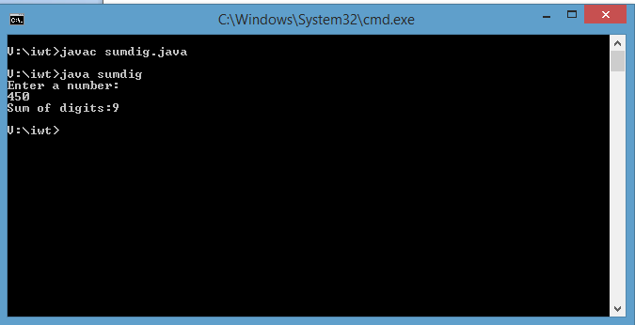

2.Write a Java program to calculate the sum of two integers and return true if the sum is equal to a third integer.

**program:**

import java.util.*;

class sum

{

public static void main(String args[])

{

Scanner sc=new Scanner(System.in);

int a,b,c,sum;

boolean result;

System.out.println("Enter three number:");

a=sc.nextInt();

b=sc.nextInt();

c=sc.nextInt();

sum=a+b;

if(sum==c)

{

result=true;

}

else

{

result=false;

}

System.out.println("Your answer is "+result);

}

}

**output:**

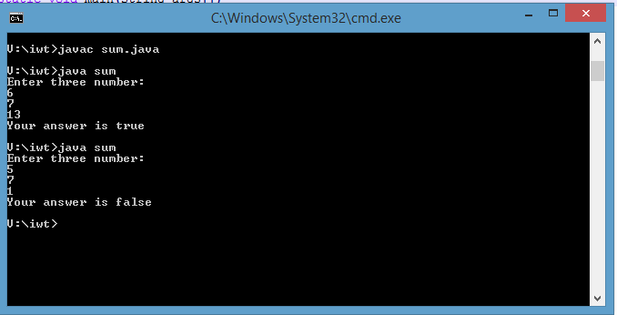

**3. Write a Java program to get the difference between the largest and smallest values in an array of integers. The length of the array must be 1 and above.**

**program:**

import java.util.Arrays;

import java.util.*;

public class diff1

{

public static void main(String[] args)

{

Scanner sc=new Scanner(System.in);

int a[]=new int[5];

int max,min;

System.out.println("Enter 5 numbers;");

for(int i=0;i<5;i++)

{

a[i]=sc.nextInt();

} max= a[0];

min = a[0];

for(int i = 1; i < a.length; i++)

{

if(a[i] > max)

max =a[i];

else if(a[i] < min)

min = a[i]; }

System.out.println("Difference between the largest and smallest values of the said array: "+(max-min)); } }

**output:**

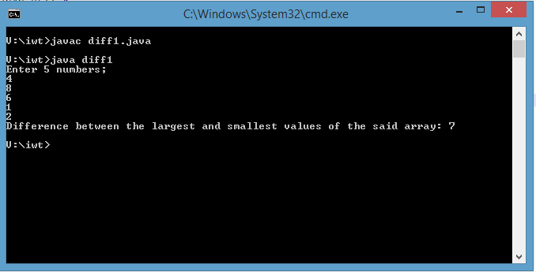

**4. Write a Java program to count all vowels in a string using function.**

**program:**

import java.util.*;

class diff

{

String str;

int count=0,i;

void countvowel(String a)

{

System.out.println("The given string is:"+a);

char[] a1 = a.toCharArray();

for( i=0;i<a1.length;i++)

{

if(a1[i]=='a'||a1[i]=='e'||a1[i]=='i'||a1[i]=='o'||a1[i]=='u'||a1[i]=='A'||a1[i]=='E'||a1[i]=='I'||a1[i]=='O')

{

count=count+1;

}

}

System.out.println("The number of vowels in the string is:"+count);

}

public static void main(String args[])

{

diff d=new diff();

d.countvowel("Internetandweb");

}

}

**output:**

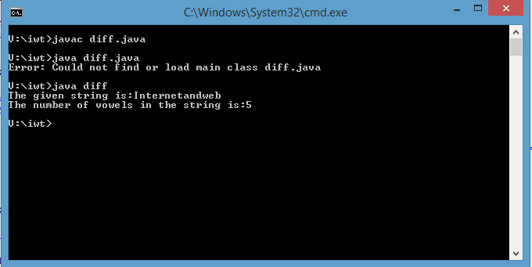

5. Develop a java program for storing elements and finding top two elements of an array.

**Program:**

import java.util.ArrayList;

import java.util.List;

public class Find {

public static void firstlast(List<Integer> list)

{ System.out.println("ArrayList contains: " + list);

if (list != null && !list.isEmpty()) {

System.out.println("Last element is: "

+ list.get(list.size()-1));

System.out.println("Last before element is: "

+ list.get(list.size() - 2));

return;

}

}public static void main(String[] args)

{ List<Integer> al = new ArrayList<Integer>();

al.add(3);

al.add(1);

al.add(4);

al.add(5);

al.add(2);

firstlast(al);

} }

**Output:**

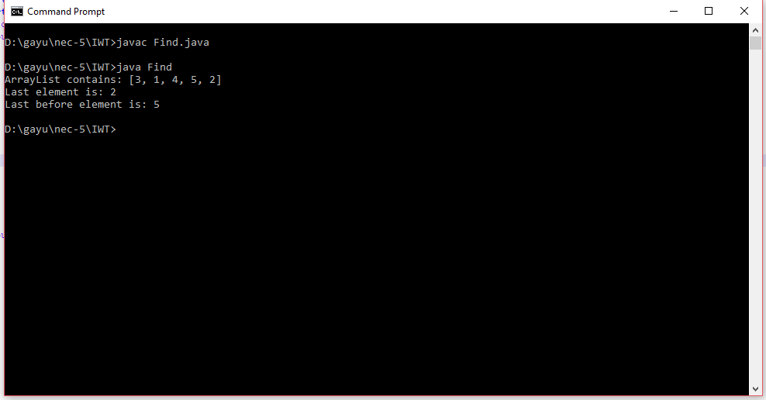

6. Develop a java program to reverse a string (without using built in function).

**Program:**

import java.util.*;

class store

{ public static void main(String args[])

{

Scanner sc=new Scanner(System.in);

System.out.println("Enter string to reverse:");

String str = sc.next();

String reverse = "";

for(int i = str.length() - 1; i >= 0; i--)

{

reverse = reverse + str.charAt(i);

}

System.out.println("Reversed string is:");

System.out.println(reverse);

} }

**Output:**

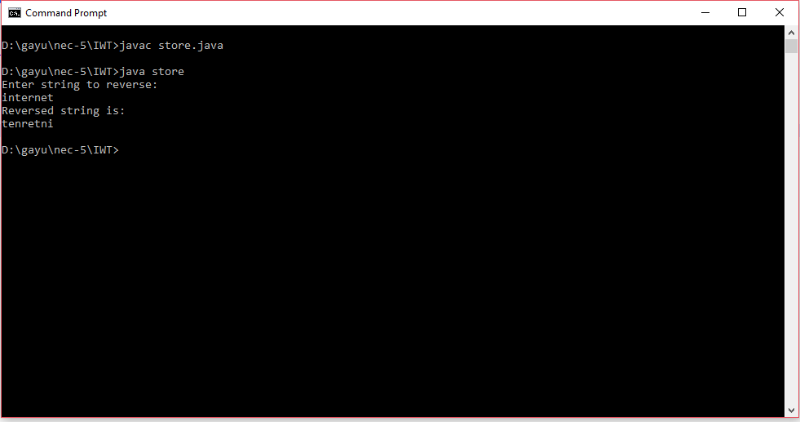

7. Write a java program to swap two numbers without using temporary variables.

**Program:**

import java.util.*;

class swap

{

public static void main(String args[])

{

Scanner sc=new Scanner(System.in);

int x,y;

System.out.println("Enter two number:");

x=sc.nextInt();

y=sc.nextInt();

System.out.println("Before swapping the values are:"+x+" "+y);

x=x+y;

y=x-y;

x=x-y;

System.out.println("Swapped values:"+x+" "+y);

}

}

**Output:**

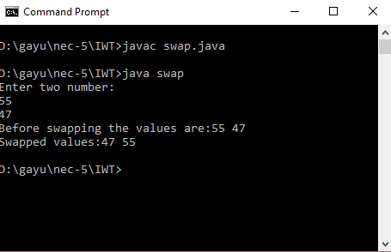

8. Develop a java program to display sum of all prime numbers from 1 to 30.

**Program:**

import java.util.*;

class prime

{

public static void main(String args[])

{ int n,a,i,j,sum=0;

for(i=1+1;i<30;i++)

{ a=1;

for(j=2;j<=i/2;j++)

{

if(i%j==0)

{

a=0;

break;

}

}

if(a==1)

{

sum=sum+i;

}

} System.out.println("Sum of prime numbers between 1 to 30 is:"+sum);

}

}

**Output:**

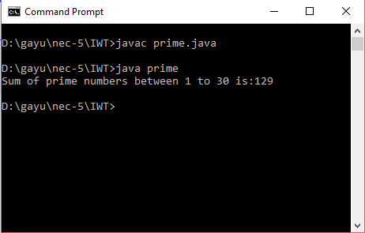

9. Develop a java program to read the contents from the user through keyboard and

write the contents into a separate file named write.txt.

**Program:**

import java.util.*;

import java.io.*;

class cont

{

String str;

Scanner sc=new Scanner(System.in);

void get()

{

System.out.println("Enter the contents to store it in a file:");

str=sc.nextLine();

}

void show()throws FileNotFoundException

{

try

{

File f=new File("D:/write.txt");

FileOutputStream fos=new FileOutputStream(f);

PrintWriter pw=new PrintWriter(fos);

System.out.println("Your contents are:"+str);

pw.write(str);

pw.println();

pw.flush();

fos.close();

pw.close();

}

catch(FileNotFoundException e)

{

System.out.println(e);

}

catch(IOException e1)

{

System.out.println(e1);

}

}

public static void main(String args[])throws FileNotFoundException

{

cont c=new cont();

c.get();

c.show();

}

}

**Output :**

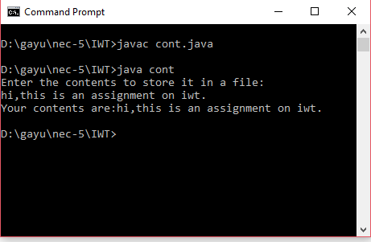

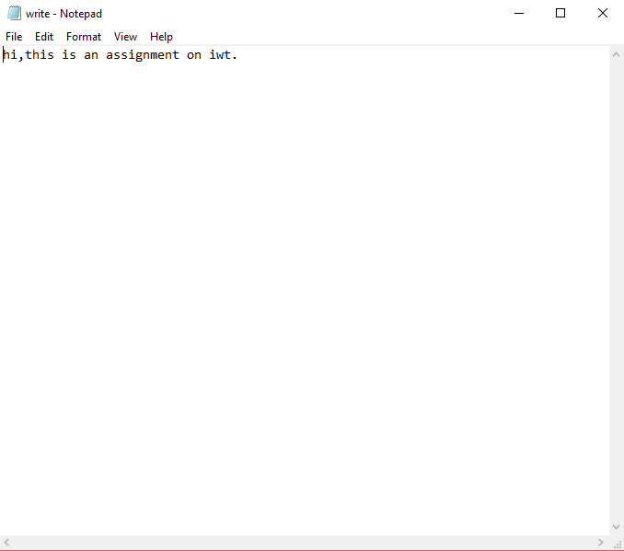

10. Write a java program to calculate the factorial of a given number using recursive functions.

**Program:**

import java.util.*;

class fact

{

static int factorial(int a)

{

if(a==1)

{

return 1;

}

else

{

return factorial(a-1)*a;

}

}

public static void main(String args[])

{

Scanner sc=new Scanner(System.in);

int n;

System.out.println("Enter the number:");

n=sc.nextInt();

int ff=factorial(n);

System.out.println("Factorial of the number is: "+ff);

}

}

**Output:**

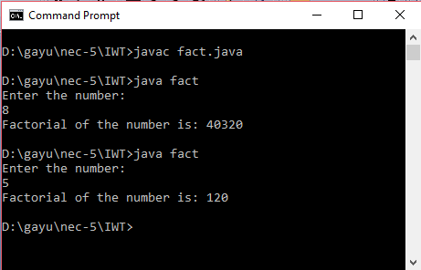

11. Develop a java program to count the number of characters, words and lines in a text file.

**Program:**

import java.io.*;

class wcl

{

public static void main(String[] args)

{

BufferedReader reader = null;

int charCount = 0;

int wordCount = 0;

int lineCount = 0;

try

{

reader = new BufferedReader(new FileReader("D:\\write.txt"));

String currentLine = reader.readLine();

while (currentLine != null)

{

lineCount++;

String[] words = currentLine.split(" ");

wordCount = wordCount + words.length;

for (String word : words)

{

charCount = charCount + word.length();

}

currentLine = reader.readLine();

}

System.out.println("Number Of Characters In A File : "+charCount);

System.out.println("Number Of Words In A File : "+wordCount);

System.out.println("Number Of Lines In A File : "+lineCount);

}

catch (IOException e)

{

System.out.println(e);

}

finally

{

try

{

reader.close();

}

catch (IOException e)

{

System.out.println(e);

}

}

}

}

**Output:**

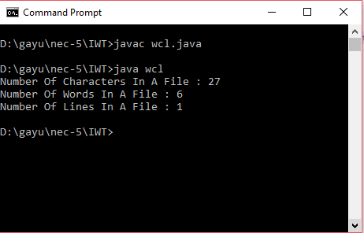

**Text file:**

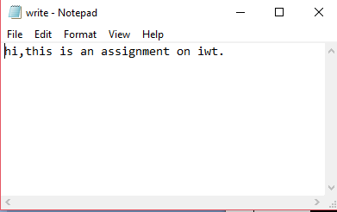

|  |
| --- |
| **Done by:**  **M.GAYATHRI**  **3rd year-CSE-‘A’**  **REG.NO:1712022** |